Access reg.uncg.edu Forms

Purpose:
This should be a procedure to fix common issues when trying to access secure forms on the University’s registrar website. This will also walk you through creating bookmarks directly to these forms.

Requirements:
- Be a UNCG faculty/staff member.

Why the change?:
Recently, the reg.uncg.edu website was updated. The new version of the website requires users visit reg.uncg.edu to correctly provision their accounts. We have created this document to address issues when navigating to the forms hosted by the Registrar’s Office. The process listed here is important for keeping these forms to staff and faculty only, as we do not want students submitting these forms on their own.

Procedure steps:
- In order to manually create a bookmark, we’ll need to identify your browser, starting with Google Chrome.
- Click on the 3 vertical dots in the top-right corner. From this drop down menu, we’ll select “Bookmarks and lists”, and then “Bookmark manager”.
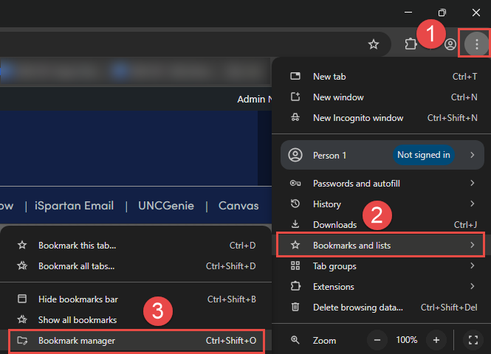
- Click on the 2nd set of 3 vertical dots, then “Add New Bookmark”. (The image below should be animated. If it does not have animation, please click it to begin.)
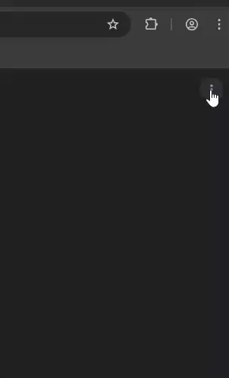

- This is where you’ll add the information for the desired form bookmark. “Name” can be whatever you like, but “URL” will come from the table below. Make sure to copy and paste it exactly as it is shown.
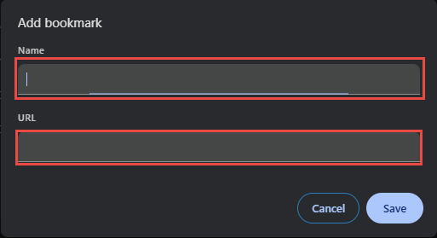

- Mozilla Firefox:
- Select the 3 horizontal lines in the top-right corner. Click “Bookmarks” from the drop-down menu, then “Manage bookmarks”. (The image below should be animated. If it does not have animation, please click it to begin.)
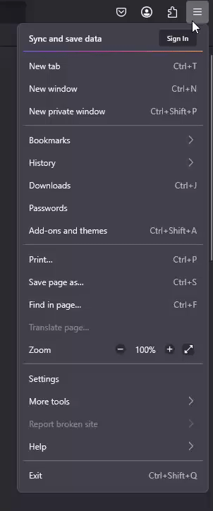

- A new window will open. Select which folder you’d like to add the bookmark to on the left side, then select “Organize” on the top bar, then “Add Bookmark”. (The image below should be animated. If it does not have animation, please click it to begin.)
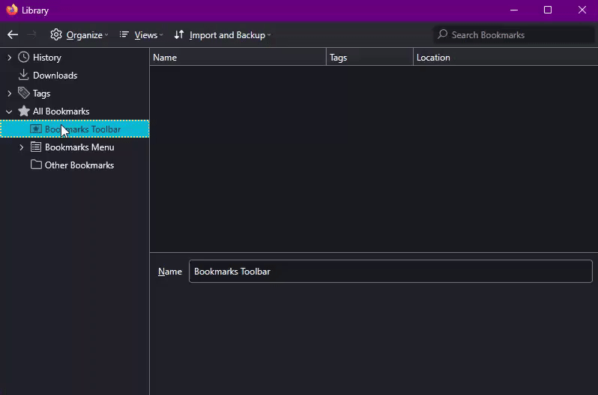

- The next window has only 2 fields we need to fill. “Name” can be whatever you like, but “URL” should be copied from the table below. Once completed, click “Save”.
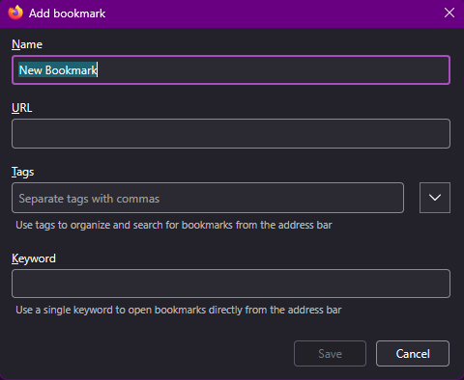

Table of links:
Form name: | Form link:
Advisor Appeal for General Education Credit | https://reg.uncg.edu/wp-login.php?redirect_to=/faculty-and-staff-forms-2/advisor-appeal-for-general-education-credit/
Change of Catalog Year | https://reg.uncg.edu/wp-login.php?redirect_to=/faculty-and-staff-forms-2/change-of-catalog-year/
Departmental Request for Student Curriculum Modification | https://reg.uncg.edu/wp-login.php?redirect_to=/faculty-and-staff-forms-2/departmental-request-for-student-curriculum-modification/
Integrative Community Studies Grade Report Request | https://reg.uncg.edu/wp-login.php?redirect_to=/faculty-and-staff-forms-2/integrative-community-studies-grade-report-request/
MAC Administrative Review | https://reg.uncg.edu/wp-login.php?redirect_to=/faculty-and-staff-forms-2/mac-administrative-review/
Maximum Credit Hours Increase Form | https://reg.uncg.edu/wp-login.php?redirect_to=/faculty-and-staff-forms-2/maximum-credit-hours-increase-request/
Request for Waiver of Student Fees (Internships Only) | https://reg.uncg.edu/wp-login.php?redirect_to=/faculty-and-staff-forms-2/request-waiver-of-student-fees/
Withdrawal/Cancellation due to Class Non Attendance (Faculty) | https://reg.uncg.edu/wp-login.php?redirect_to=/faculty-and-staff-forms-2/withdraw-cancellation-due-to-class-attendance-faculty/

Improvements and Suggestions:
If there are changes to the website or it’s authentication policies, this document should be updated with those changes in the future.

